Nama : Dimas Shofa Gunarso

NIM : 18090061

Kelas : 5D

Laporan Praktikum 5

1. Source Code

MatakuliahValidation.php 🡪 application/controllers/

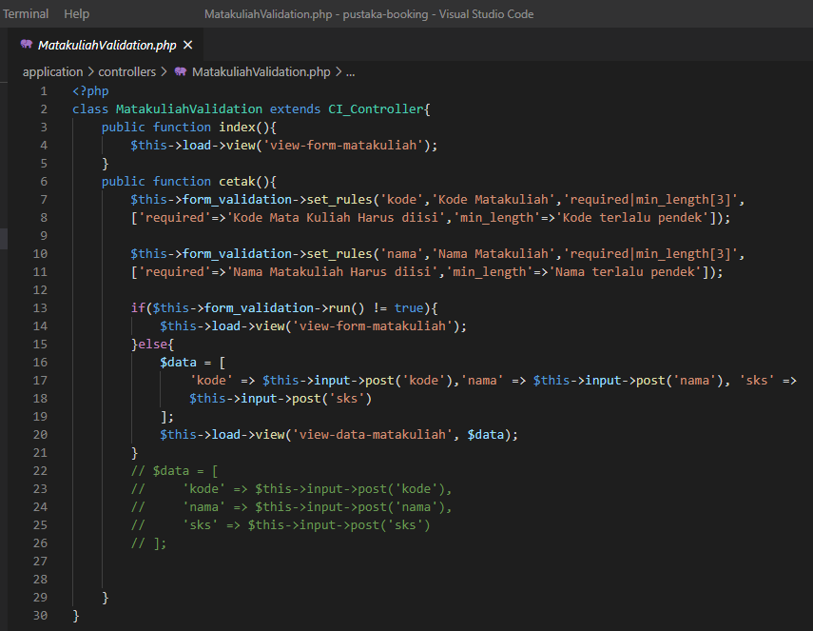

autoload.php 🡪 application/config/

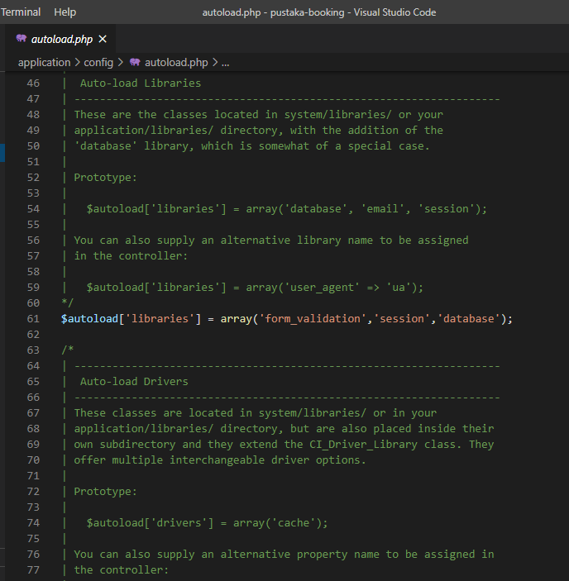

view-form-matakuliah.php 🡪 application/views/

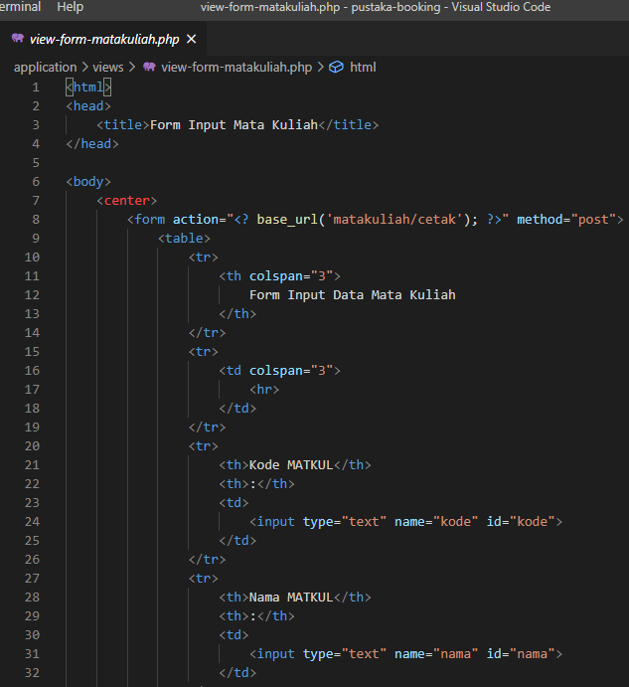

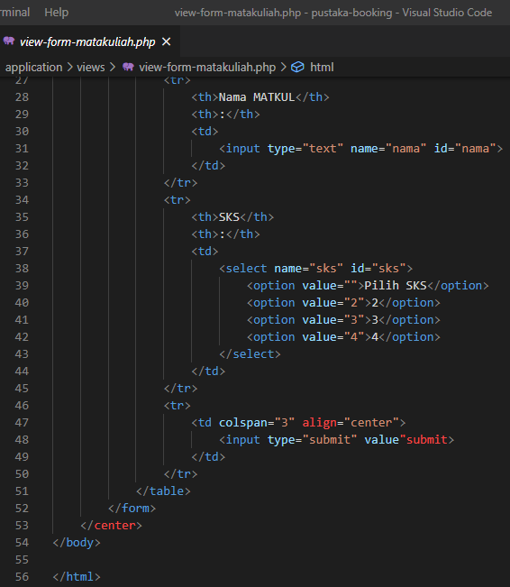

1. URL

<http://localhost/pustaka-booking/MatakuliahValidation>

1. Capture Output Program

